results

songs

nine songs were generated for each of fifty cent and johnny cash and a fusion one

the fusion one is still running

suggested excerpts:

“This worries bump, I can't go wrong, my team's too strong

You want war? I take you to war, now that my money long”

“I change places, to prevent catchin' the cases

Races, in the faces, hall at you laces”

YES IT EVEN RHYMES OMG

“well, the good to your hair

if god would but

grant me the power

just to take you”

the johnny cash one is not quite as good

Preliminary fusion lyrics:

“fiends askin from the streets of see the fire little mornin', and my piece years and blues

it's really, they wanna rob me”

approach

Lyrical corpora 500,000 characters long were generated from the artistic portfolios of the singers Johnny Cash and 50 Cent. These artists were chosen in recognition of their contributions to the genres of country music and rap music, respectively. Their songs were assembled in separate textual documents, and arranged consecutively.

To create a fusion training set of Johnny Cash and 50 Cent, lyrics for both songs were appended. This was allowable considering the character level representation of the feature matrixes extracted in subsequent steps.

The lyrics were read through Python. This includes, all characters presented within the corpora. Upon reading, the data was enumerated into discrete indices and in the process all text was cut into semi-redundant sections. At the end of feature extraction, if a character existed in a sentence, it was then placed into a matrix. The vertical axis of the matrix was section index and the horizontal axis was word index.

To accomplish text generation, a stacked LSTM RNN with used. RNN stacking allows greater model complexity, combining synergistically with the long short-term memory feature of the recurrent neural net. Indeed, the effect is towards finer description of hidden feature details. For the LSTM implementation itself, the Keras library was used in combination with the Theano scientific computing library. The Macbook Pro's Intel Iris graphics processor was recruited to accelerate training time using its one gigabyte of processing power.

The results were run for fifty epochs of training time each, spanning approximately a week of computation. After which, the models were “unwound,” generating nine songs of two-thousand five-hundred characters each.

Conclusions

100% accuracy for Rap and Country generation using the NN classification

Models:

A typical LSTM memory cell

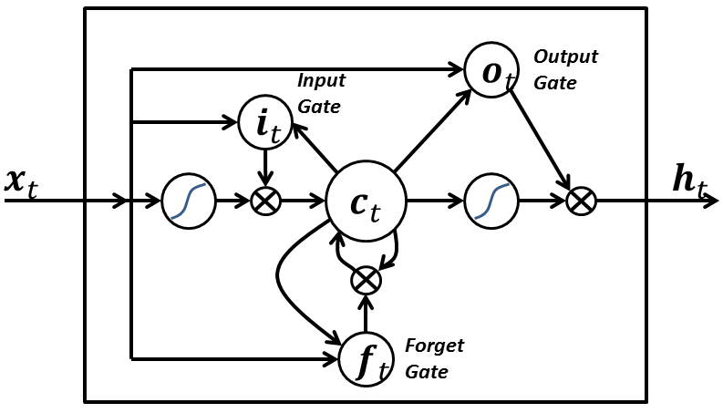

A typical unrolled LSTM

